The Platform Tavern Easter
Craft Ale, Music & Tapas Festival
Tasting Notes
Dancing Man Bone Dry I.P.A. 4.0% £3.70/£1.85
Mega dry, light & hoppy session IPA. Mosaic & Rakau hops really pop with lemon & tropical fruit notes
Dancing Man Vagrant Pale Ale 4.5% £3.80/£1.90
Mega simple, mega modern & mega drinkable a way to show off the beauty of the fantastic centennial hop variety
Dancing Man Organ Grinder I.P.A. 6.0% £4.10/£2.05
We brew it only occasionally and we use the freshest & funkiest hops in the brewery at the time. It’s a ballsy IPA designed to grind your taste buds into submission with an aggressive bitterness, massive hop flavour and aroma to die for.
Dancing Man Little Casino Double I.P.A. 7.5% £4.20/£2.10
Our anniversary ale. Lush buttery wafers with lemon curd. Hoppy and sticky. Bitter and sweet. Blood orange citrus and pine. Handle with care!
Hop Stuff A.P.A (Arsenal Pale Ale) 3.8% £3.60/£1.80
Massive citrus & tropical fruit hops. A low ABV, high flavour beer.
Dark Star Wheat Purple Blackberry Wheat Beer 4.2% £3.70/£1.85
A classic wheat beer enhanced during the brewing process with the addition of blackberries for a subtle fruity edge to the beer.
Thornbridge Ashford New World Brown Ale 4.2% £3.70/£1.85
The nose is of roasted malts, coffee, chocolate, dark cherries. The taste is initially bitter and dry, but sugary sweet notes begin to show themselves.
Thornbridge Sequoia American Amber Ale 4.5% £3.80/£1.90
Beautiful citrus and pine notes. Smooth and velvety, a medium body with hints of roasted hazelnut, toffee and caramel malt flavours.
Thornbridge Melba Peach I.P.A. 5.2% £3.90/£1.95
Peach IPA brewed by DAda in Sheffield as part of the Thornbridge Taps Landlord Challenge
Arbor Oz Bomb Aussie Pale 4.7% £3.80/ £1.90
Heavily hopped golden bitter brewed with a small amount of caramalt & plenty of Australian galaxy plus Vic secret hops. It has tropical fruit flavours & aromas with a long bitter finish
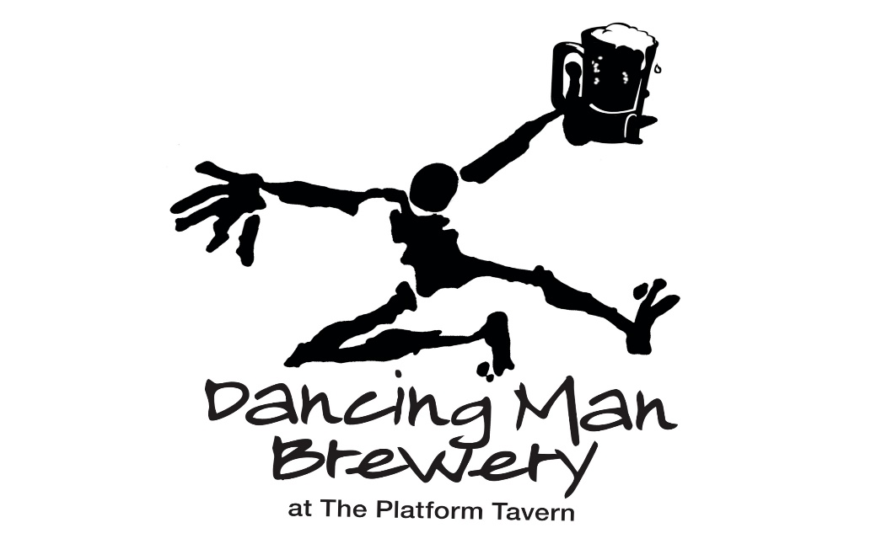

And on the Bar (When available)

Dancing Man Fiddlers Jig New World Special Bitter 4.8% £3.80/£1.90
Fiddlers Jig is a traditional English style special bitter with punchy modern American hops. Harmonious balance between hops and malt make for very easy drinking in an olde timey, fiddle tuney, jig dancing, olde English pub kind of way!
Dancing Man Screwface Sour Gose Kegged Sour Ale 4.0% £4.00/£2.00
Dancing Man’s first kettle sour. Slightly salted& dry hopped with Nelson hops. Very refreshing & puckerly sour!
Wild Beer Bibble Pale Ale 4.2% £3.70/£1.85
Brewed with Vienna Malt and Oats, an amazing mouth filling malt base. Hopped with beautiful Mosaic hops, renowned for their tropical fruit beauty, helped along with some nice orangey Amarillo hops both at the end of the boil and in the dry hop. It is unfined, so naturally hazy. A moreish bitterness is complimented by tropical fruit tastiness.
Ilkley Tribus 1.7 Pale 4.4% £3.70/£1.85
Our 3-hop pale series continues with this, our seventh incarnation. Slovenian hops have often been understated with the rise of popularity of American and Southern Hemisphere hops. This is a mix of old and some first-of-their-kind Slovenian hops. The hops give a lemony citrus nose, but with a nice spicy herbal balance.
Dark Star Antares Red Ale 4.2% £3.70/£1.85
This giant red ale packs a celestial punch of malts and hops, delivering a copper glow in a glass.

